**Feedback Control Systems**

**Lab Report 4**

**Hafiz Ahmad**

**19l-1316**

**Section-6B2**

Mathematical Modeling of Physical Systems

**INTRODUCTION:**

We must mathematically model the physical systems in order to determine how they operate. This lab teaches how to model an electrical and mechanical system. In the lab, we had to figure out the system's differential equation before finding the transfer function or the other way around. After finding the transfer function, we need to put the system into action in Matlab and watch for impulse and step responses.

**OBJECTIVES:**

* To understand the role of mathematical models of physical systems in design and analysis of control systems.
* To learn MATLAB functions in solving and simulating such models.

**Procedure:**

**Task 1**

1. **Derive the second order differential equation of the mass-spring system and write it down in the space below:**

Fa(t)= $M\ddot{x}\left(t\right)+B\dot{x}\left(t\right)+kx\left(t\right)$

1. **Write the transfer function of the system:**
$$\frac{x\left(s\right)}{F\left(s\right)}=\frac{1}{Ms^{2}+Bs+k}$$

2. **Write the state space equation of the above system in the space below:**
$$\left[\frac{x_{1}^{'}}{x_{2}^{'}}\right]=\left[\begin{matrix}0 & 1 \\ -\frac{k}{M} & \frac{-B}{M}\end{matrix}\right]\left[\begin{aligned}x_{1} \\ x_{2}\end{aligned}\right]+\left[\begin{aligned}0 \\ \frac{1}{M}\end{aligned}\right]F_{a}\left(t\right)$$

3. **Construct a SIMULINK diagram to calculate the response of the Mass-Spring system. The input force increases from 0 to 8 N at t = 1 s. The parameter values are M = 2 kg, K= 16 N/m, and B =4 N.s/m (Draw a block diagram to represent this equation and draw the corresponding SIMULINK diagram before implementing it on SIMULINK).**
4. 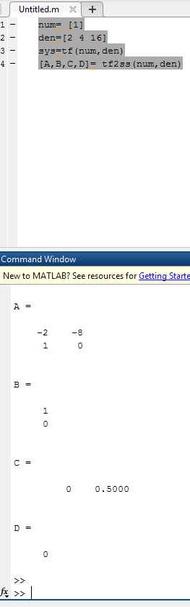

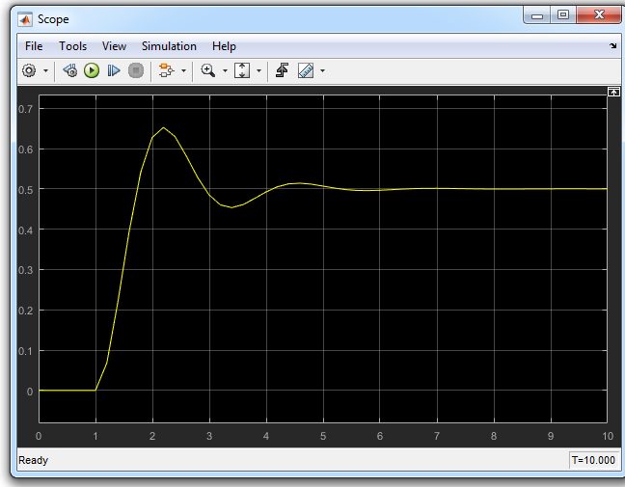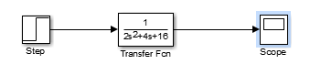

**Task 2**

**Parta**

1. **Derive the differential equation of the above systems and write it down in the space below, also state its order:**
$$8\ddot{y}\left(t\right)+6\dot{y}\left(t\right)+y\left(t\right)=6\dot{x}\left(t\right)$$

2. **Write the transfer function of the systems in the space below:**

$$\frac{6s}{8s^{2}+6s+1}$$

**c) Write the state space equation of the above system in the space below:**

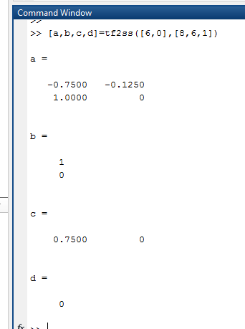

**d) Construct a SIMULINK diagram to calculate the response of the above systems. Use 𝑅 = 3, 𝐿 = 4 𝑎𝑛𝑑 𝐶 = 2 (Draw a block diagram to represent the equations and draw the corresponding SIMULINK diagram before implementing it on SIMULINK).**

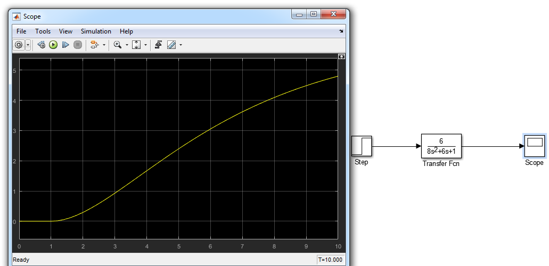

**Part B);**

1. **Derive the differential equation of the above systems and write it down in the space below, also state its order:**
$$24\ddot{y}\left(t\right)⊢4\dot{y}\left(t\right)+3y\left(t\right)=3x\left(t\right)$$

2. **Write the transfer function of the systems in the space below:**
3. **Write the state space equation of the above system in the space below:**

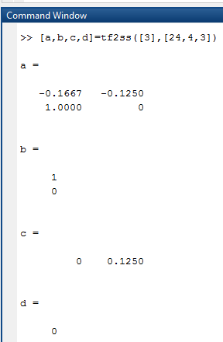

1. **Construct a SIMULINK diagram to calculate the response of the above systems. Use 𝑅 = 3, 𝐿 = 4 𝑎𝑛𝑑 𝐶 = 2 (Draw a block diagram to represent the equations and draw the corresponding SIMULINK diagram before implementing it on SIMULINK).**

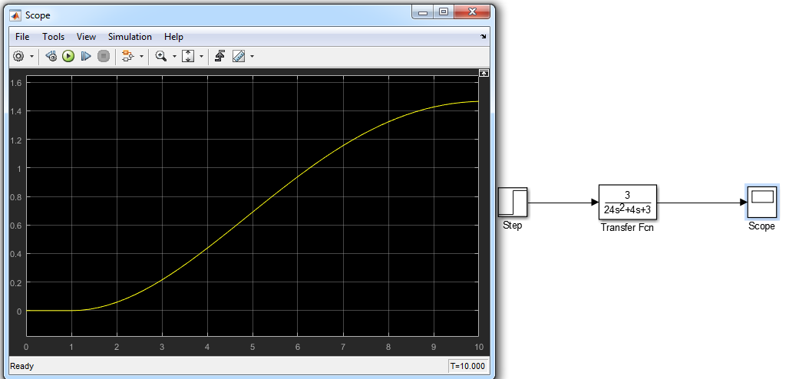

**Partc)**

1. **Derive the differential equation of the above systems and write it down in the space below, also state its order:**
$$24\ddot{y}\left(t\right)+4\dot{y}\left(t\right)+3y\left(t\right)=24\ddot{x}\left(t\right)$$

2. **Write the transfer function of the systems in the space below:**
3. **Write the state space equation of the above system in the space below:**

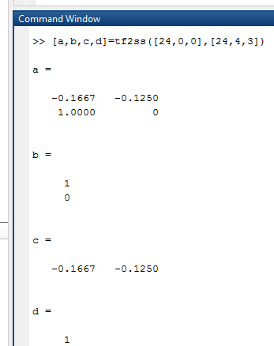

1. **Construct a SIMULINK diagram to calculate the response of the above systems. Use 𝑅 = 3, 𝐿 = 4 𝑎𝑛𝑑 𝐶 = 2 (Draw a block diagram to represent the equations and draw the corresponding SIMULINK diagram before implementing it on SIMULINK).**

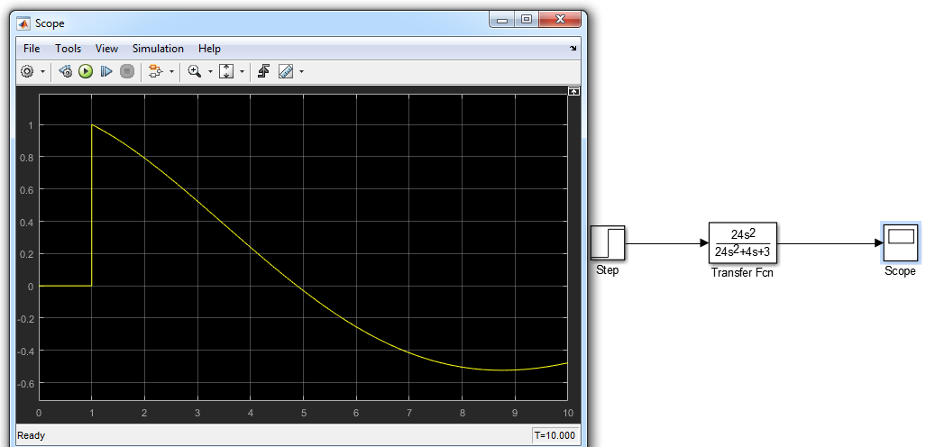

**Application:**

When designing a control system, a system's block diagram can be provided by mathematical modeling of the system.

**Issues:**

No issue found while performing the lab.

**Conclusion:**

In this lab we learn to use MATLAB and Simulink to solve these systems and find the mathematical equations for the physical models from this lab.